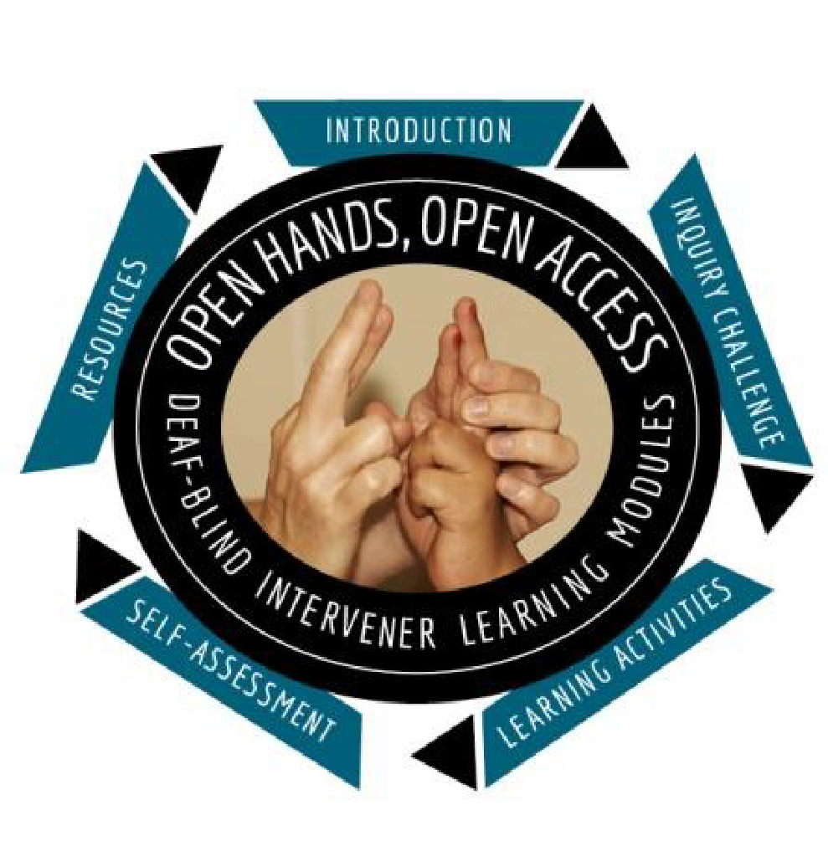
Open Hands, Open Access: DeafBlind Learning Modules

Sponsored by the Minnesota Low Incidence Projects and the Minnesota DeafBlind Project

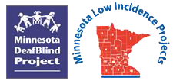

Begins June 23, 2020 - Ends August 4, 2020 - Online registration deadline: June 12, 2020

Fee: FREE to participants in previous teacher and intervener cohorts.

Target Audience: Teachers and interveners serving Minnesota children and youth who are deafblind, but open to other licensed staff who have participated in a previous OHOA cohort.

Register online at: click this to go to Metro ECSU registration site. On the calendar, find June 23 and select either the Teacher OHOA Modules Summer Cohort or the Intervener OHOA Modules Summer Cohort. An immediate confirmation will arrive at the email address submitted. If a confirmation does not arrive, contact Ann Mayes to confirm the registration.

Registration and Program Questions: Ann Mayes 612-638-1527 | click this to send Ann Mayes an email message

Training description: The Open Hands Open Access (OHOA) DeafBlind Learning Modules are a national resource designed to increase awareness, knowledge, and skills related to intervention for students who are deafblind and are being served in educational settings (ages 3 – 21).

The training includes:

Hosted module format with engaging case studies, videos, slideshows, short readings, interactive group discussions and more.

Learning from experts, teachers, interveners, individuals with deafblindness, and families.

Distance coaching, course CEUs.

Only 1-2 hours per week are needed to complete the modules. Both modules will be open at the same time to allow participants flexibility to complete them between June 23 and August 4, 2020. The deadline for both modules is firm.

Guided coursework using two (2) online modules of the training series, only offered during our special summer cohorts.

Hosted by Ann Mayes, the Statewide DeafBlind Specialist for the Minnesota Low Incidence Project and the Education Specialist for the Minnesota DeafBlind Project. For 30 years, Ann taught students who are deaf, deafblind and hard of hearing, including at a charter school and in intermediate programs for deaf/hard of hearing students. She has taught students who are deafblind both in general education and special education settings. She has presented to many teachers about students who are deaf/hard of hearing, including children with additional disabilities as well as those with deafblindness. She has four grown children, three who have been deafblind interveners. She and her husband live in Eagan with their two dogs who make the empty nest warmer.

Facilitated by Tina Hertzog a retired teacher of students with visual impairments with 33 years in the field, most of them as an itinerant teacher in Berks County, Pennsylvania. She completed graduate work at Texas Tech University in the area of deafblindness, where, in 2010, she was chosen to represent the university as a Helen Keller Fellow. That fellowship gave her the opportunity to be an Open Hand Open Access (OHOA) Module contributor for all four cohorts of module creation. Currently, Tina hosts OHOA modules for several state cohorts and also provides private deafblind consultation for school districts. Tina lives in Hamburg, Pennsylvania with her husband of 42 years, has two grown sons and a five-year-old grandson whom she spoils endlessly.

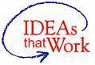
Funding for this initiative is made possible with a grant from the MN Department of Education. The source of the funds is federal award Special Education – Programs to States, CFDA 84.027A and Special Education – Technical Assistance and Dissemination to Improve Services and Results for Children with Disabilities, CFDA 84.326T. The activity does not necessarily represent the policy of the federal Department of Education or the state Department of Education and you should not assume endorsement by the federal or state government.

